Full ranger 8ohm, woofer 4ohm
- overlap: LP on woofer 400Hz, HP on full ranger 100Hz low 3.6ohms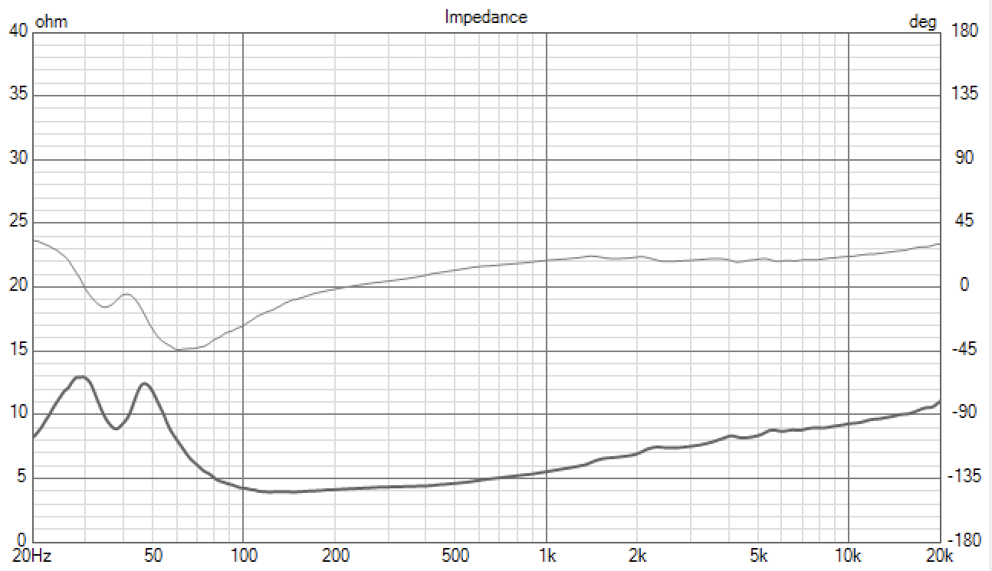

- hole: LP on woofer 200Hz, HP on full ranger 800Hz low 4.3ohms
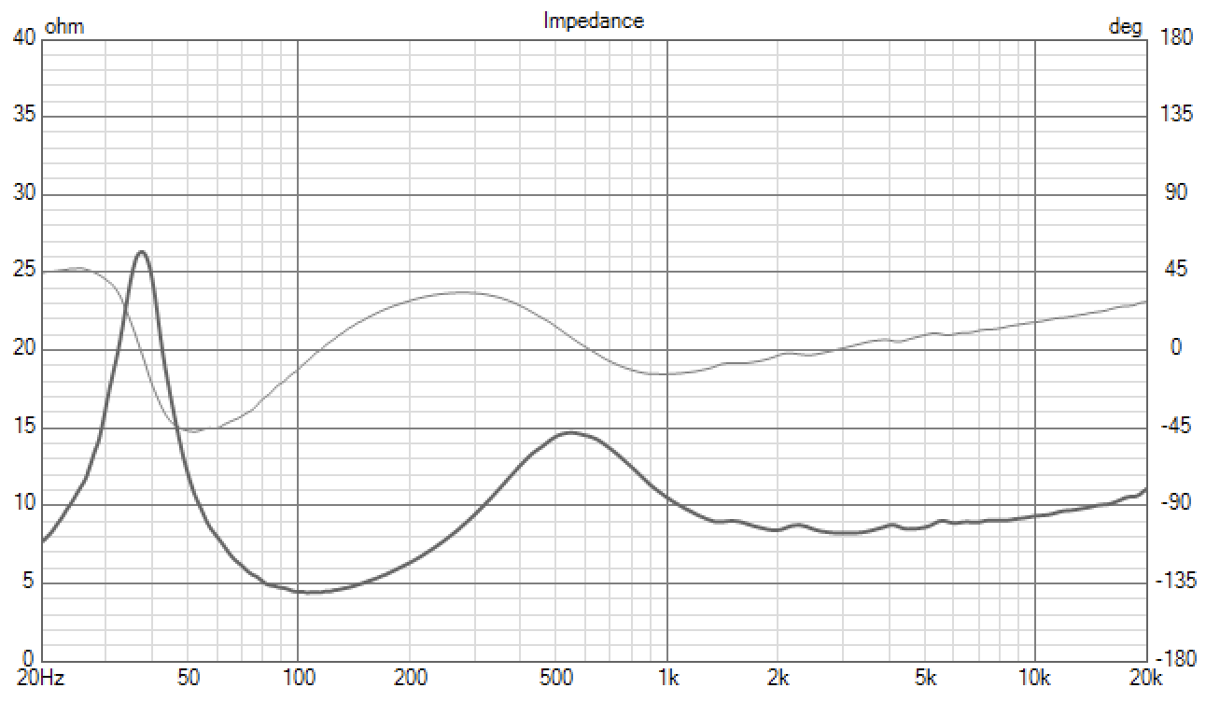

- small overlap: LP on woofer 190Hz, HP on full ranger 150Hz low 3.8ohms
- 